**Hospital Name**

**Retreat Planner**

*Shaping the Anytown Community Hospital’s Future*

Date

**Background and Process Overview**

Located in Anytown, New York, Anytown Community Hospital (ACH) serves more than 100,000 residents in Anytown, Anycity and Anyvillage counties. Originally incorporated in 1889 and opened in 1893, the mission of Anytown Community Hospital is to provide the communities it serves “with high-quality, comprehensive health care services in a dignified and compassionate environment.” The 200-bed acute care hospital concentrates its services on advanced surgery, primary care and health education. The organization also operates a 120-bed long-term care facility and 24 primary and specialty care centers. ACH has focused on advancing its care through innovative programs and investment in new facilities and equipment.

The hospital’s vision is:

“Insert the hospital's vision statement.”

ACH will host a strategic planning retreat on day(s) and date(s). The hospital’s #-member board of trustees and senior leaders will meet to explore the organization’s challenges, issues and opportunities in preparing for a successful future. The retreat will provide a forum in which ACH’s leadership can be fully engaged in:

* A review of the organization’s mission and vision;
* Discussion and deliberations about issues that require attention and strategic opportunities that may be seized;
* Determination and prioritization of broad initiatives for the organization’s future; and
* Discussion of the leadership skills, expertise and resources necessary to achieve ACH’s vision for the future.

**Pre-Retreat Survey**

The retreat agenda will be shaped by the results of a pre-retreat survey that will assess the viewpoints of ACH board members and senior leaders in the following areas:

* Relevance of the ACH mission and vision as a foundation for the future;
* ACH’s effectiveness in exhibiting its core values;
* Desired strategic priorities for ACH in 20__;
* Dominant issues and challenges facing ACH;
* Major objectives to be achieved in the next three to five years;
* Significant organizational strengths and assets that contribute to mission achievement;
* Major weaknesses or liabilities that may prevent mission achievement;
* Critical factors in areas relevant to ACH’s success;
* Most needed and valuable areas of governance strength and knowledge building; and
* Thoughts about desired retreat outcomes.

Identify who is responsible for the following, e.g. The Strategic Planning Committee will plan and oversee facilitation of the retreat. Executive leadership will be responsible for the design and production of customized retreat support materials (e.g. name tents, retreat agenda and background materials, as appropriate). The retreat agenda will be shaped in part by the results of the pre-retreat survey and the retreat objectives.

**Strategic Assessment and Chartbook**

To further assist ACH in its strategic planning efforts, executive leadership will develop a *Strategic Assessment and Chartbook* that will include information on a range of national health care “forces for change” and trends, creating a valuable and comprehensive resource for board members and hospital leadership. The contents will include, but are not limited to, the following:

* Strategic issues (as identified from the pre-retreat survey results)
* Reaffirmation of ACH mission and vision viability as a foundation for the future
* Significant organizational strengths and assets that contribute to mission achievement
* Critical weaknesses or liabilities that may prevent mission achievement
* Dominant issues facing ACH
* Primary objectives to be achieved in the next five years
* Significant characteristics defining ACH’s marketplace situation
* Financial and operating performance
  + Financial indicators
  + Operating indicators
* The ACH market
  + Demographic trends
  + Socioeconomic indicators
* Forces for change
  + Economic pressures
  + Changing demographics
  + Workforce shortages
  + Information and medical technology
  + Rising consumer activism
  + Demands for transparency in quality, patient safety and cost
  + Value-based purchasing, pay-for-performance
  + Scrutiny of hospitals’ not-for-profit status
  + Government intervention
  + Form 990
  + Patient Protection and Affordable Care Act (ACA)
* Service Line Strategic Analyses
  + Influence of trends and other factors on future success
  + Service line potential

**Follow-up**

Executive leadership will develop a retreat report, including a summary of the pre-retreat survey results, decisions made, the outcomes from breakout groups, significant discussions, any decisions made and the retreat evaluation results.

**Draft Retreat Agenda**

**(For internal planning and review purposes only - *DO NOT DISTRIBUTE*)**

**Day, Date**

|  |  |  |
| --- | --- | --- |
| **Time** |  | **Activity** |
|  |  |  |
| **7:30 a.m.** |  | Continental Breakfast |
| **8:00 a.m.** |  | Welcome and Introductions (Board Chair, CEO) |
| **8:05 a.m.** |  | Retreat overview and objectives (Retreat Facilitator) |
| **8:15 a.m.** |  | Establishing the Landscape: (Retreat Facilitator)   * Key environmental trends and forces for change * Employee satisfaction survey findings * Board member and leadership insights and viewpoints (pre-retreat survey findings) |
| **9:00 a.m.** |  | ACH Mission and Vision (Retreat Facilitator)  Challenges, Strengths and Weaknesses |
| **10:15 a.m.** |  | *Break (15 minutes)* |
| **10:30 a.m.** |  | Envisioning ACH’s Strategic Future (Retreat Facilitator) |
| **11:15 a.m.** |  | Identification of the most critical strategic issues and questions (Retreat Facilitator) |
| **Noon** |  | *Lunch break (30 minutes)* |
| **12:30 p.m.** |  | Breakout group discussions of key strategic issues (All) |
| **2:45 p.m.** |  | *Break (15 minutes)* |
| **3:00 p.m.** |  | Breakout group reporting and full group discussions (All) |
| **4:00 p.m.** |  | Wrap-up and next steps (Retreat Facilitator, Board Chair, CEO) |
| **4:30 p.m.** |  | Adjourn |

|  |  |  |
| --- | --- | --- |
| **Retreat Logistics** | | |
|  |  | |
| **Retreat Date:** | Date | |
| **Location:** | The Hotel | |
| **Theme:** | “Shaping the ACH Future” | |
| **Meeting Times:** | Day, date and beginning/end times | |
| **Invited Participants** | Board Members  Name, Chairperson  Name, MD, Vice-Chairperson  Name, Treasurer  Name, Secretary  Name  Name, MD  Name  Name  Name  Name  Name  Name, MD  Name  Name  Name | ACH Staff & Other Invitees  Name, President and CEO  Name, Chief Operating Officer  Name, Chief Financial Officer  Name, MD, Medical Director  Name, Executive Assistant  Facilitators  Name, Consulting Company  Name, Consulting Company |
| **Equipment Required &**  **Responsibility for Providing** | Projection screen (Venue)  Table for LCD projector and laptop computer (Venue)  Laptop computer (ACH)  LCD projector (ACH or Venue) | Power cord to table, and power strip Venue)  (4) easels for flip charts (Venue)  (4) 3-M brand flip charts (ACH)  Supply of new marking pens (ACH) |
| **Contact Information** | *Name:*  *President and CEO*  OFFICE TELEPHONE:  MOBILE:  EMAIL:  *Name:*  *Executive Assistant*  OFFICE TELEPHONE:  MOBILE:  EMAIL: | Facilitator's Name, Company Name  ADDRESS:  CITY, STATE, ZIP CODE  OFFICE TELEPHONE:  FAX:  MOBILE:  EMAIL:    Venue  The Hotel  123 Sleeping Lane  OFFICE TELEPHONE: 555-567-8910  FAX: 555-567-8911  EMAIL: info@thehotel.org |

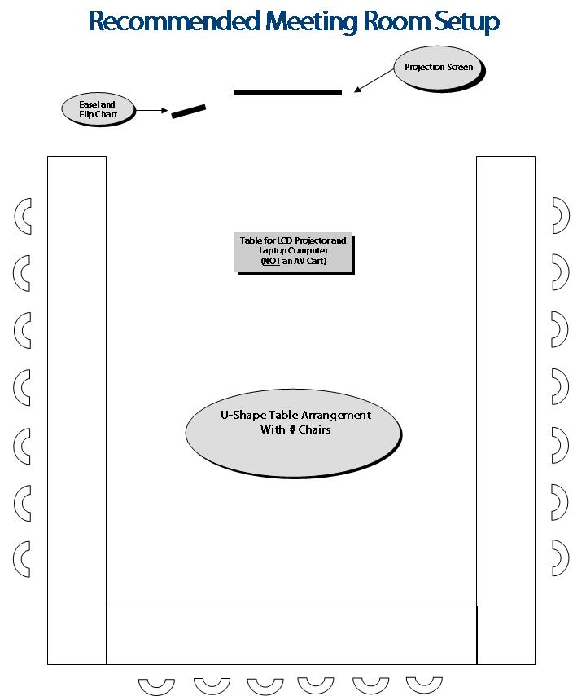

**Roles and Responsibilities**

|  |  |  |  |  |  |
| --- | --- | --- | --- | --- | --- |
|  | **Activity** |  | **Responsibility** |  | **Time Frame** |
| **Pre-Retreat** | Conference call to discuss draft survey, retreat plans |  | ACH and/or Consultant |  | Not later than three months prior to retreat |
| Determine retreat location |  | ACH |  | Not later than two and a half months prior to retreat |
|  | Determine retreat participants |  | ACH |  | Not later than two and a half months prior to retreat |
|  | Approve retreat objectives |  | ACH |  | Not later than two and a half months prior to retreat |
|  | Notifications to participants: Retreat purpose, save the date and details |  | ACH |  | Not later than two and a half months prior to retreat |
|  | Confirm retreat equipment requirements |  | ACH |  | Not later than two and a half months prior to retreat |
|  | Implement pre-retreat survey |  | TBD/Consultant |  | By eight and a weeks prior to retreat |
|  | Design first draft survey |  | TBD |  | By eight and a half weeks prior to retreat |
|  | Review, make modifications |  | ACH |  | By eight weeks prior to retreat |
|  | Finalize survey |  | TBD |  | By seven weeks prior to retreat |
|  | Email survey to participants (Deadline for closing survey is (date) |  | ACH |  | By six weeks prior to retreat |
|  | Send 1st reminder email |  | ACH |  | By four weeks prior to retreat |
|  | Send 2nd reminder email |  | ACH |  | By three and a half weeks prior to retreat |
|  | Extend survey deadline and send final reminder, if necessary |  | ACH |  | By three weeks prior to retreat |
|  | Close survey, download results |  | TBD/Consultant |  | By two and a half weeks prior to retreat |
|  | Compile survey results and distribute report to retreat participants with Chartbook (below) for review prior to retreat |  | TBD/Consultant |  | By ten days prior to retreat |
|  | Create retreat materials: name tents, PowerPoint® presentation, breakout group materials, retreat evaluation |  | TBD/Consultant |  | By one week prior to retreat |

**Roles and Responsibilities *(continued)***

|  |  |  |  |  |  |
| --- | --- | --- | --- | --- | --- |
|  | **Activity** |  | **Responsibility** |  | **Time Frame** |
| **Strategic Assessment and Chartbook** | Collect, analyze and compile national health care trends, local statistics and related data for the environmental assessment |  | TBD-ACH and/or consultant |  | By six to eight weeks prior to retreat |
| Collect, analyze and compile demographic data for market analysis |  | TBD-ACH and/or consultant |  | By six to eight weeks prior to retreat |
|  | Synthesize data into a draft “ACH Strategic Assessment and Chartbook” |  | TBD-ACH and/or Consultant |  | By four weeks prior to retreat |
| Review and approval of “ACH Strategic Assessment and Chartbook” |  | ACH |  | By three weeks prior to retreat |
| Create “ACH Strategic Assessment and Chartbook” PDF for electronic distribution, or print and assemble 3-ring binder of Chartbook materials for distribution |  | TBD-ACH and/or Consultant |  | By two weeks prior to retreat |
| Distribute “ACH Strategic Assessment and Chartbook”to retreat participants for review prior to retreat |  | ACH |  | By ten days prior to retreat |
|  |  |  |  |  |  |
| **Retreat Roles** | Retreat welcome and introductions |  |  |  | Day of retreat |
| Retreat presentation and facilitation |  |  |  | Day of retreat |
|  | Meals and breaks |  |  |  | Day of retreat |
|  |  |  |  |  |  |
| **Post Retreat** | Send note of thanks and appreciation to retreat participants |  | ACH |  | Within one week following retreat |
| Develop retreat report |  | Consultant |  | Within two to three weeks following retreat |
|  | Conference call to discuss retreat report, determine next steps based on outcomes |  | Consultant/ACH |  | Within three to four weeks following retreat |
|  |  |  |  |  |  |